**MINI PROJECT**

**Fairvote : An online voting portal**

TEAM MEMBERS:

SANIKA BAGWE -1811065

SMIT BHATT -1811070

ANIKET JOSHI-1811083

(BATCH-B1 GROUP-1)

**Table of Contents:**

**Chapter 01: Introduction** ...…………………………………………………………….**3**

1.1 Problem definition…………………………………………………………………3

1.2 Scope ….….……………………………………………………………………….3

1.3 Hardware and software requirements ……………………….……………………3

**Chapter 02: Literature Survey** ……………………………………...…………………**4**

2.1 Collection of Data…………………………………………………………………4

2.2 Characteristics.…………………………………………………………………....4

2.3 Links…...…………………………………………………………………….........4

**Chapter 03: Project Design** ……………………………………………...……………..**6**

3.1 Proposed System Model………………………………...…………………….......6

3.2 Module wise flow ……………..………………………………………………….8

3.3 Software Project Management Plan………………….………………………........8

3.4 Software Requirements….………………………...………………………………9

**Chapter 04: Implementation and Testing** …………………………………...……….**10**

4.1 Proposed System Model Implementation ……………………………………….10

4.2 Software testing …………………………………………………………………17

4.3 Experimental results and its analysis ……………………………………..……..20

4.4 Github Link ………………………………………………………….………..…20

**Chapter 05: Conclusion and further work** …………………………….………..........**21**

5.1 Conclusion …………………………………………………………….………...21

5.2 Further Work ………………………………………………………….……..…..21

**References** ………………………………………………………………………………**22**

**Acknowledgement** ……………………………………………………………………...**22**

**CHAPTER 01**

**INTRODUCTION**

**Problem Definition :**

Online Election System for the post of General Secretary of the student council of KJSCE. Admin login which will be handled by responsible authorities. Candidate and Voters can register/login using existing Somaiya email ID’s. At the time of registration there is two factor authentication via email to ensure originality.The system allows Voters to view a list of Candidates and choose wisely.Voter/Candidate can vote for a Candidate only once per Election.The system allows the Candidate to login in to their profiles once registered,and they can also update their bio and profile picture. The admin can check each Candidate details and can remove candidates which are not eligible for elections.The admin has overall rights over the system. The system also allows to display the result at the end of the election.

## **Scope of the project:**

* The extent of this system is limited to the students of SY comps B for testing purposes.
* Design interfaces as per need. Eg interface for voter login, candidate login,admin login etc.
* To process and handle appropriate data.
* To identify and define data/database/data structure needed for this project(input output).
* To have appropriate form validation for voter and candidate (non Somaiya ID’s)
* To implement two factor authentication
* To validate the candidates profile(by admin).
* To conduct unbiased election
* Display the results of the election after voting

**CHAPTER 02**

**LITERATURE SURVEY**

As the world watched the electoral drama unfold in Florida at the end of 2000, people started wondering, “Wouldn’t all our problems be solved if they just used Internet Voting?”. People all over the world soon started taking a hard look at their voting equipment and procedures, and trying to figure out how to improve them [1]. There is a strong inclination towards moving to Remote Internet Voting – at least among the politicians – in order to enhance voter convenience, increase voter confidence and voter turnout.

The voting system that uses electronic devices to either aid or take care of casting and counting votes is termed as e-voting system. The paper based voting system is replaced by the e-voting. Nowadays to decrease the load of man power and delay in result declaration of voting result e-voting system is more in demand by private or public organizations. It also saves papers which are made up of trees which will eventually save the natural disasters.

Since 1960 e-voting systems are being used when the punched card system appeared and was used in seven different counties in the US for the presidential election of 1964 and nowadays it has become a very practical way of voting. Electronic voting has many advantages over the traditional way of voting. Some of these advantages are lesser cost, faster tabulation of results, greater accuracy

Thus for college elections too we should have online voting portal as it has so many advantages over the traditional system.But along with this we need to have the security and privacy of voter’s/candidate’s information.

The voting system must guarantee the following Characteristics:

• Eligibility and Authentication: Authorized voters are only able tovote.

• Uniqueness:One voter is allowed to vote to once.

• Accuracy: Voted should be recorded correctly.

• Integrity: Modification or loss of online data should not happen which may lead to failure of the system

• Reliability:System must be designed such that it can be stable even after failures and loss of internet.

For the project, below is the list of various links/references that have been used throughout:

[1]<https://www.w3schools.com/>[/](https://codepen.io/) : Used for choosing various colour schemes for the webpages. Provides tutorials for web development using HTML, CSS, javascript,. It also provides tutorials for canvas used for graphics and animations.

[2]<https://www.geeksforgeeks.org/> : Used for getting information about how to design and implement various modules.

[3]<https://getbootstrap.com/> : An open source toolkit for developing with HTML, CSS, and JS used for styling the web pages.

[4] <https://pypi.org/project/Flask/>: This documentation provided us information about various flask modules

[5] [https://codepen.io](https://codepen.io/): Used for designing the UI .

The objective of the literature survey was to understand the topic chosen and analyse the topic so as to know the basic requirements needed and accordingly design and implement the same along with the modifications that the existing projects of similar kind do not have.

**CHAPTER 03**

**PROJECT DESIGN**

Module 1- Welcome page

This module contains login options for candidates and admin

Module 2- Candidate

This module contains the login and registration page for candidate. Candidate dashboard for viewing the candidate form and updating bio and profile picture.

Module 2- Voter

This module contains login and registration page for voter. Voter dashboard for viewing the eligible candidate list.

Module 4- Admin operations

This module contains login page for admin.Admins approve the pending applications of the registered candidates

Module 5-Voting

This is where registered voters and candidates can vote and is a common page to both.

Module 6- Result

This is the page where result of the election will be displayed and van be viewed by everyone.

Module 7- Database design

The database contains the information of all the candidates, voter and admin information.

**Module wise flow-**

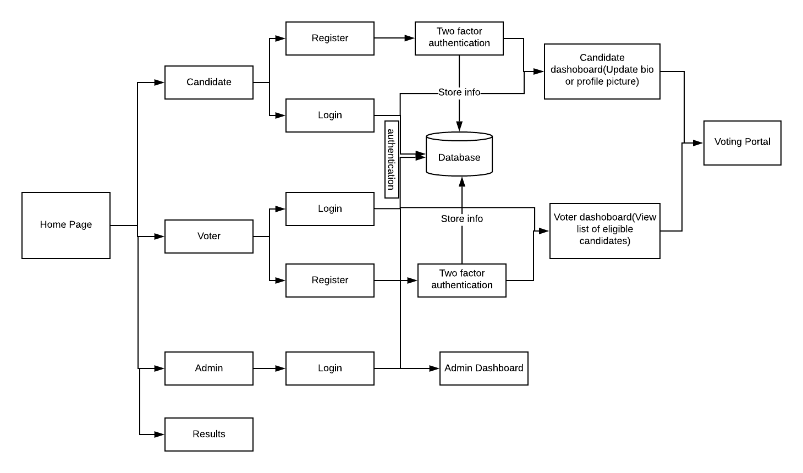

**Software Project Management Plan :**

|  |  |  |  |
| --- | --- | --- | --- |
| **Task** | **Member1 Sanika Bagwe** | **Member2 Smit Bhatt** | **Member 3 Aniket Joshi** |
| **UI :** |  |  |  |
| **Design** | **X** |  |  |
| **Coding** | **X** | **X** | **X** |
| **Database :** |  |  |  |
| **Table design** | **X** | **X** | **X** |
| **Query design** | **X** | **X** | **X** |
| **Coding** | **X** | **X** | **X** |
| **Program:** |  |  |  |
| **Home Module** | **X** |  |  |
| **Admin Module** |  | **X** |  |
| **Candidate Module** | **X** |  |  |
| **Voter Module** |  |  | **X** |
| **Results** |  |  | **X** |
|  |  |  |  |
| **Testing approach** | **X** | **X** | **X** |
| **Test Cases** | **X** | **X** | **X** |
| **Presentation:** |  |  |  |
| **Powerpoint** |  | **X** |  |
| **Report** | **X** |  | **X** |

##### **The programming languages we are using are-**

##### Python(Flask)

##### HTML

##### CSS

##### PHP myadmin- for creating database

##### Java script

##### **The tools we will use are**

##### Vscode

##### Lucidchart for diagrams

##### Sublime Text Editor

##### Xampp

##### 

##### 

##### 

##### **Chapter 4**

**Implementation of the project**

We have implemented the project using Flask framework along with a MySQL database for the back end. For front end we have used HTML, CSS, Bootstrap and JavaScript to make the website look aesthetic and user friendly.

For using the system we first need to register either as a voter or a candidate. These modules can be accessed easily through the homepage.

The major functions implemented in the project are given below.

**Flask functions-**

mysql.connector.connect()- used for connection with the database to extract data.

app.route()- Used for routing the user to the different web pages while simultaneously handling other functionalities as well.

bcrypt.hashpw()- Used for hashing the password before storing it in the database.

bcrypt.checkpw()- Used to decode the hashed password and check it with another parameter.

generate_token(), mail(), verify() - Used to send mail to the registered candidate for verification purposes.(two factor authentication)

**Python functions-**

add_candidate(), add_voter()- The function accepts input from the candidate registration form and adds the details to the database through queries.

clogin_validation(), vlogin_validation()- Checks the details entered by the user and verifies them with the database

results()- Fetch the votes of all candidates from the database, order them in descending order and pass the data to the html template.

**JavaScript functions-**

FormValidation()- Ensures all the details entered by the candidate or the voter are in the proper format or not.

checkPassword()- Checks if the Password and the Confirm Password field match or not.

getElementById()- method returns the element that has the ID attribute with the specified value.

Homepage-

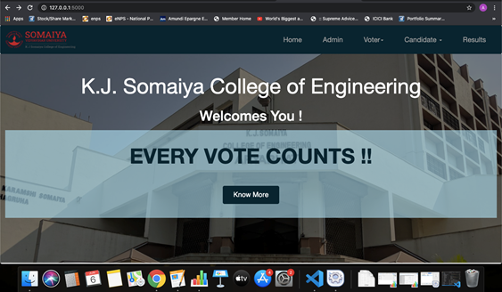

The candidates who register need to get their form approved by the admin. Once the candidate registers, he is first sent an email to his or her respective Somiaya account in which they receive a link to verify themselves. Once verified, their form is visible in the admin dashboard to the admin, who then verifies it based on authenticity. If the form is verified, the candidate is eligible to take part in the election.

Candidate Registration-

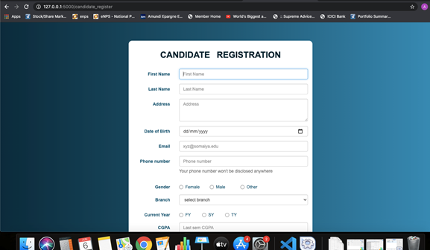Candidate login-

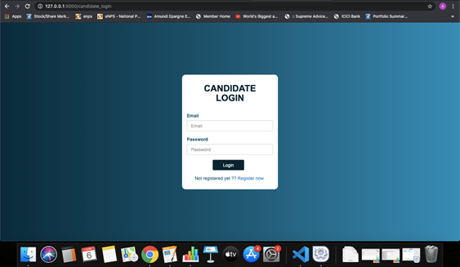

Suppose a candidate registers in the name of Riya Singh, her details will be visible to the administrator on their dashboard.

Admin dashboard-

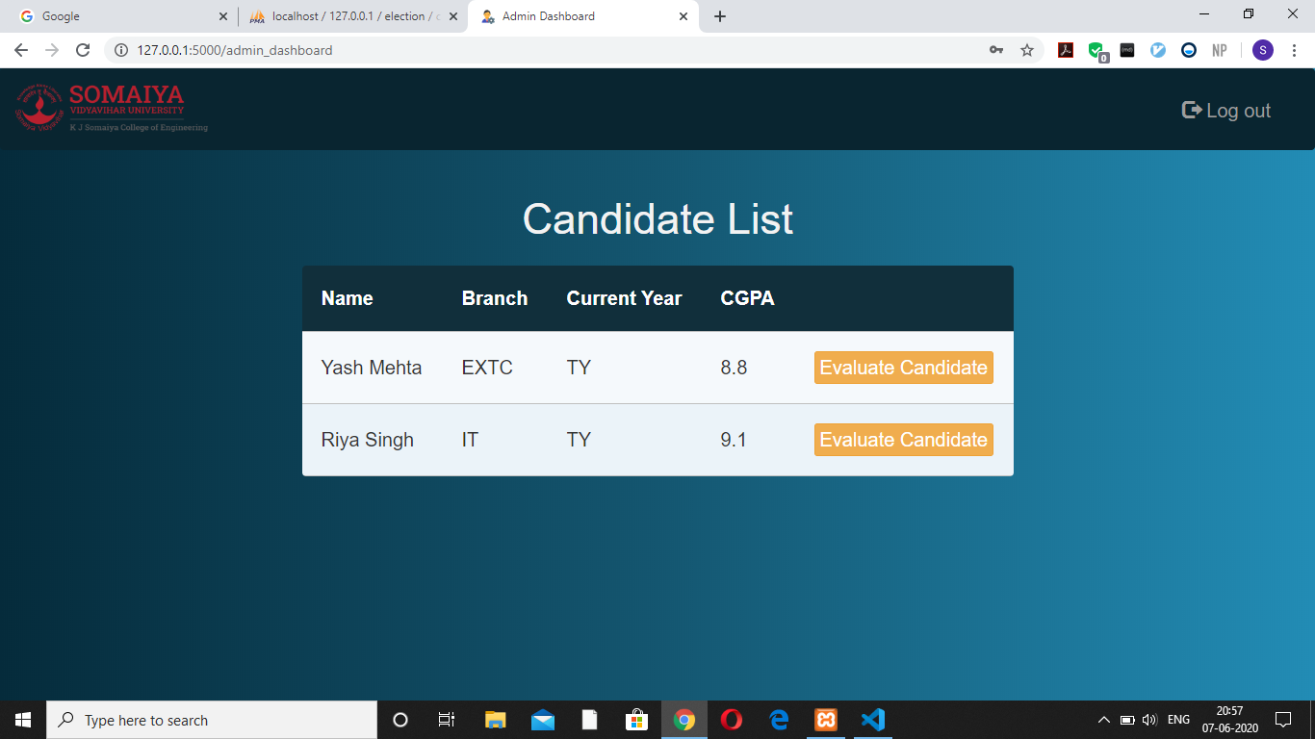

On clicking evaluate candidate, the rest of the details appear for verification. The details entered are dummy details for representation. On accepting the form, the candidate gets a message on their dashboard stating that their form has been accepted.

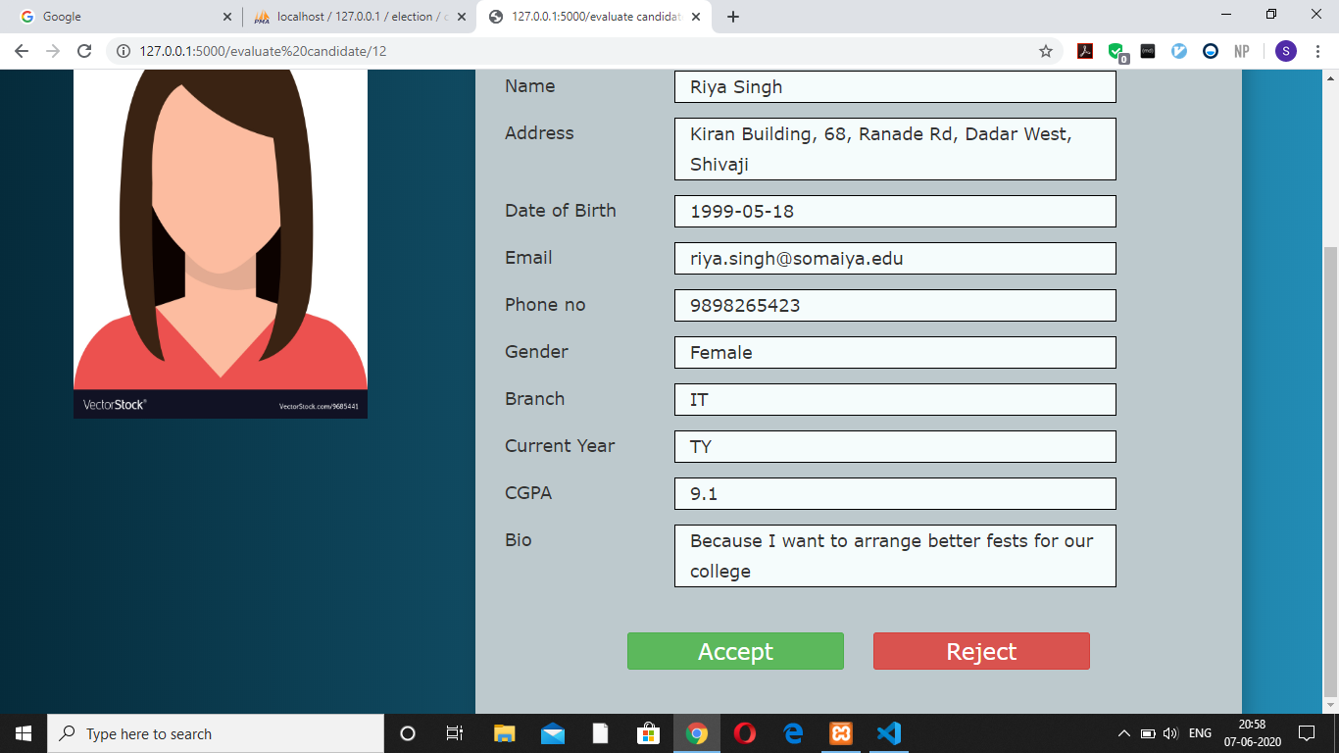

Candidate dashboard-

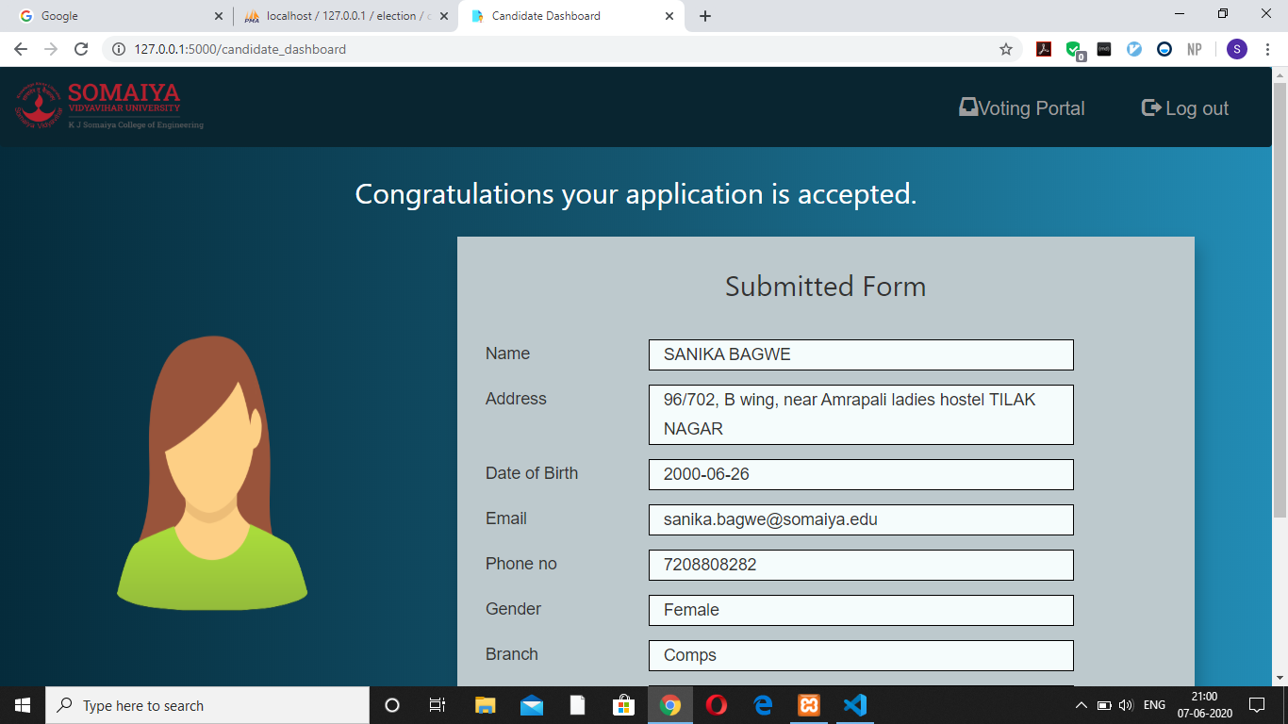

Voter Registration-

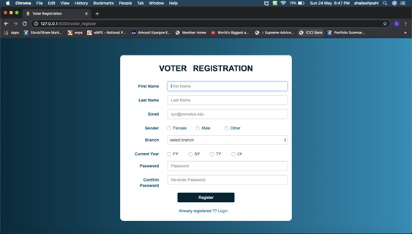

Voter Login-

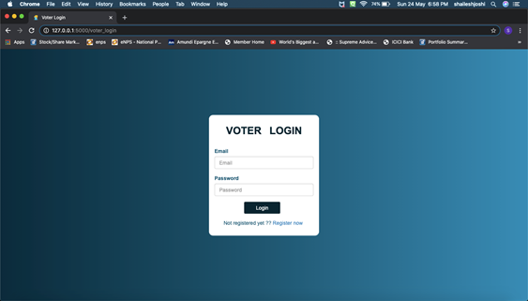

When the voter logs in to his or her respective account, they see a dashboard which contains the list of the candidates participating in the election with all their essential details. On clicking the Voting Portal option, they are redirected to the portal for casting their vote.

Voter dashboard-

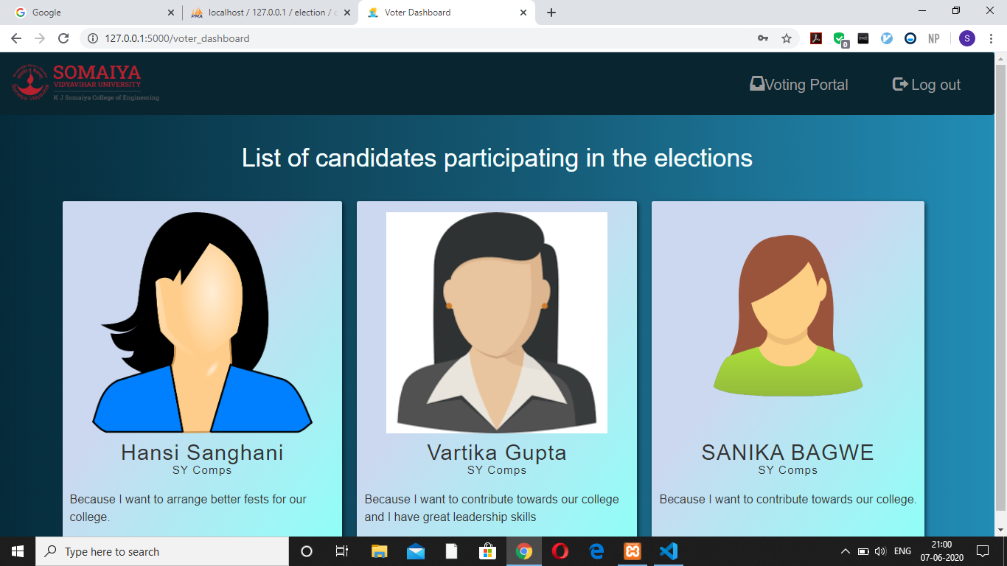

Voting Portal-

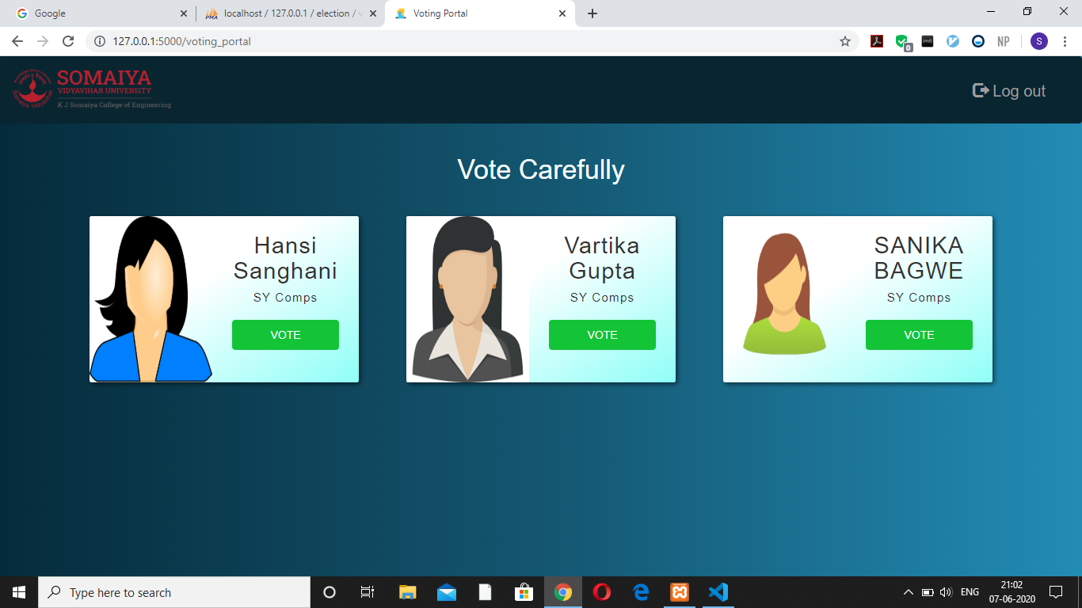

Results-

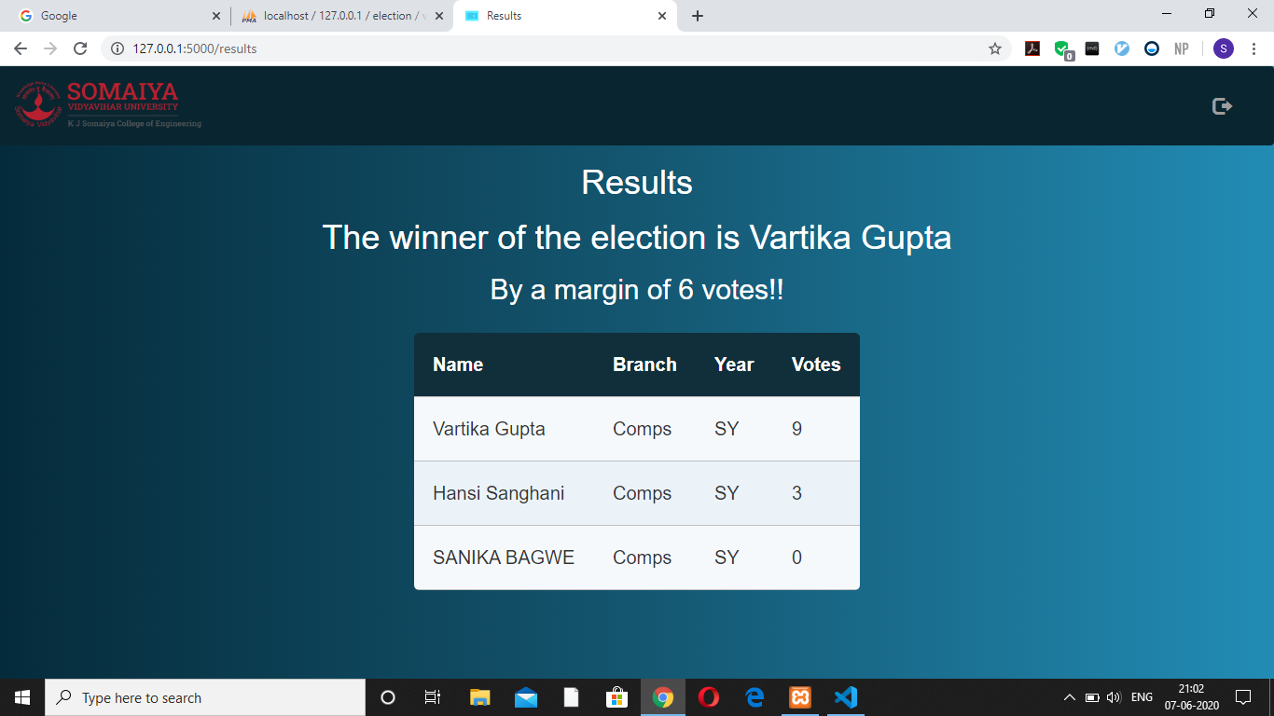

**Software Testing-**

|  |  |  |  |  |
| --- | --- | --- | --- | --- |
| **Test case** | **Description** | **Intended result** | **Actual result** | **Completed by** |
| Homepage | Displays the details of the election and provides links to access the various functionalities of the web app. | The links should redirect the user to the appropriate webpages. | Working properly. The URLs are redirecting the user to the correct webpages. | Sanika |
| Candidate and voter form validation | The validation function checks the email and password entered by the user and checks them with the database. Javascript functions used in login and registration forms to ensure all the fields are filled in the proper format. | The user should be able to login and view his profile If he has registered beforehand. Only Somaiya ID’s are allowed to register in both the cases.file uploading is also required in proper size and format. | Working properly. The users get redirected to their respective dashboards. The functions require filling of all the necessary fields in the proper formats. | Smit |
| Login Authentication | The email and password is cross-checked with the database. Password is decoded using the bcrypt library. | All the modules should login and display the dashboards of the respective modules | Working properly. The pages redirect us to the admin, candidate and the voter dashboard respectively. | Sanika |
| Candidate and Voter registration | Candidates and voters are required to register before they can access the further functionalities. The password is hashed and stored in the database for security. | The details filled by the candidates and the voters should be recorded and stored in the database successfully. | The candidate and the voter details are stored in the database. The password is hashed successfully. | Sanika, Aniket |
| Two Factor Auth | Functionality is needed for enhanced protection and ensuring authenticity.It uses json web tokens to generate link containing token. | Email is sent to the Somaiya account provided by the candidate which contains the verification link to access the candidate dashboard. | Working properly. The email is sent and the link redirects us to the candidate dashboard like expected. | Smit |
| Candidate form verification | The candidate form must be verified by the admin for originality before being displayed to the voters. | On accepting the forms, the details of the candidate should become visible to the voters when they login. | The details are visible to the voters once the form is accepted by the admin. Working properly. | Smit |
| Voting Portal | The candidate list is visible to the voter and he/she must cast their vote to the person they think to be worthy of the position. | The votes should be counted for only that candidate whom the voter votes. | Working properly. The page asks for confirmation from the user before redirecting them to the home page. | Aniket |
| Results | The results of the election are visible under this tab along with the winners name. | The list of the candidates is displayed in the decreasing order of the number of the votes they have received. | The table is getting displayed in the proper manner along with the winner | Aniket |

**Implementation result and analysis-**

The website allows us to carry out a full fledged election in a comfortable manner. The administrator has all the basic rights to the system and can filter out faulty applications. The candidates and the voters register their details and are able to vote for their choice of person.

The results of the election are displayed at the end of the election.

**Github link-**

[**https://github.com/sanb26/voting-portal**](https://github.com/sanb26/voting-portal)

**Chapter 5**

**Conclusion and further work**

**Conclusion-**

Voting is an integral part of our society since it represents our democracy. It ensures that only the person elected has been brought to power in a fair and square manner.

The application which we have developed enables the conducting authority to manage the elections in a smooth manner. The platform proves to be a viable option in contrast to the traditional ballot method of conducting elections. It also keeps in mind the need for security while voting and has two factor authentication enabled and password hashing in the database to prevent any attacks on the accounts of the users of the system.

**Future work-**

We have created this project with our utmost efforts, but there is always scope for improvement by trying out new functionalities in addition to the ones already existing and making the project more efficient.

We can further add statistical analysis on the results of the election by providing graphs and charts denoting the percentage of voters branch wise, gender wise, year wise and many more combinations.

We can further improve the user interface and provide a forgot password option to the users in case they get locked out of their accounts.

Additionally, we can facilitate a time slot based activation of the election portal so that students can vote only in that specific period.

**References-**

1. <https://youtu.be/swHI1H7DVsQ>
2. <https://codepen.io/reklamarsiv/pen/vgPLLv>
3. <https://www.w3schools.com/>
4. <https://codepen.io/geoffyuen/pen/FCBEg>
5. <https://flask.palletsprojects.com/en/1.1.x/>
6. <https://www.phpmyadmin.net/>
7. <https://www.w3schools.com/css/css_padding.asp>
8. <https://getbootstrap.com/>
9. <https://realpython.com/>

**Acknowledgement-**

We would like to thank our project guide Mr Manish Potey sir for his support and encouragement during the course of this project.

We are grateful for the Computer Department of our college for providing us with the software and resources required which helped us in the timely completion of our project. A special thanks goes to my teammates, Sanika and Smit, who helped me to assemble this project and gave suggestions and helped me out throughout this project. Last but not least, many thanks go to the head of our department, Mr. Deepak Sharma sir who has invested his full effort in guiding the department and setting up this syllabus. I have to appreciate the guidance given by other supervisors especially in our project presentation that has improved our presentation skills due to their constructive criticism and advice.